Федеральное агентство по образованию

ФГБОУ ВО Уфимский государственный авиационный технический

университет

Кафедра ВМиК

ЛАБОРАТОРНАЯ РАБОТА №4

По дисциплине: «Инженерная и компьютерная графика»

«ПРОГРАММИРОВАНИЕ WebGL ГРАФИКИ»

Выполнил: студент группы ПРО-222

Сафронов И.А.

Проверил: Котельников В.А.

Уфа 2021

1. **Цель работы:** ознакомиться с WebGL-графикой.
2. **Задачи:**

* Рассмотреть примеры компьютерной графики в html5 (открывать в IE).
* Визуализировать Солнечную систему.

1. **Ход** **работы**

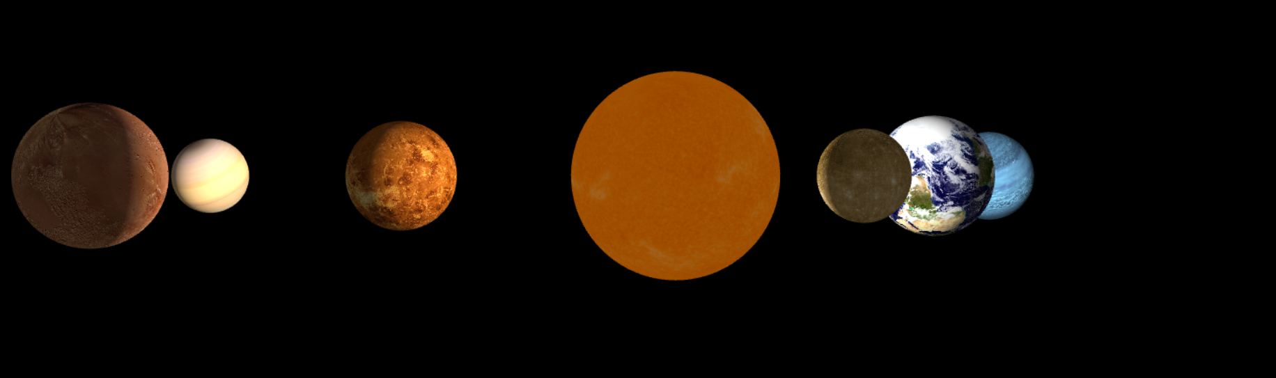

Рис. Стартовое изображение

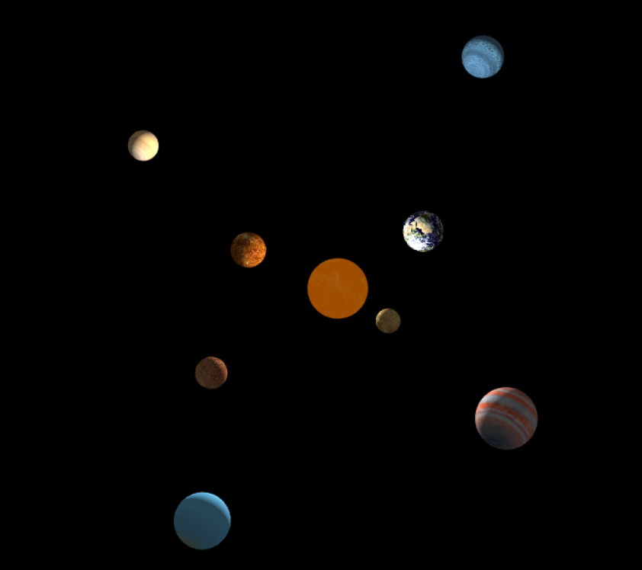

Рис. Вид сверху

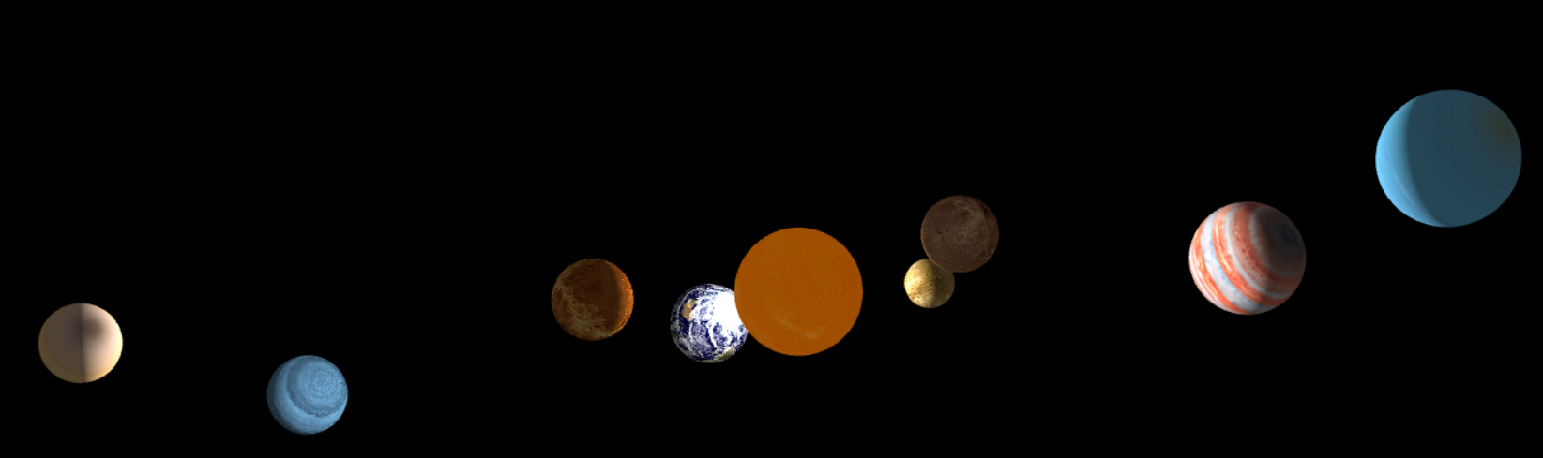

Рис. Вид сбоку

1. **Вывод:**

В лабораторной работе №4 «Программирование WebGL графики» я ознакомился с WebGL-графикой.

Приложение 1. Листинг программы:

**index.html:**

<!doctype html>

<html lang="en">

<head>

<title>Солнечная система</title>

<style>

body {

background: #000;

}

</style>

<script src="Three.js"></script>

<script src="https://threejs.org/build/three.js"></script>

<script src="Detector.js"></script>

</head>

<body>

<script>

var radius = 6371,

rotationSpeed = 0.1,

moonScale = 0.23,

height = window.innerHeight,

width = window.innerWidth,

container,

camera, controls, scene, renderer,

geometry, meshMoon,

dirLight, ambientLight,

clock = new THREE.Clock();

window.onload = function () {

if (!Detector.webgl) {

Detector.addGetWebGLMessage();

return;

}

init();

animate();

}

function init() {

container = document.createElement('div');

document.body.appendChild(container);

scene = new THREE.Scene();

renderer = new THREE.WebGLRenderer({ clearAlpha: 1, clearColor: 0x000000, antialias: true });

renderer.setSize(width, height);

renderer.gammaInput = true;

renderer.gammaOutput = true;

container.appendChild(renderer.domElement);

camera = new THREE.PerspectiveCamera(25, width / height, 50, 1e7);

camera.position.z = radius ;

scene.add(camera);

controls = new THREE.TrackballControls(camera, renderer.domElement);

controls.rotateSpeed = 1.0;

controls.zoomSpeed = 1.2;

controls.panSpeed = 0.2;

controls.noZoom = false;

controls.noPan = false;

controls.staticMoving = false;

controls.dynamicDampingFactor = 0.3;

controls.minDistance = radius * 1.1;

controls.maxDistance = radius * 1000;

controls.keys = [65, 83, 68]; // [ rotateKey, zoomKey, panKey ]

dirLight = new THREE.PointLight(0xFFFFFF,1);

dirLight.position.set(0, 0, 0).normalize();

scene.add(dirLight);

scene.add(new THREE.AmbientLight(0x404040));

var shader = THREE.ShaderUtils.lib["normal"],

uniforms = THREE.UniformsUtils.clone(shader.uniforms);

dist = 1000;

//Солнце

scene.add(new THREE.AmbientLight(0x404040));

Sun_light = new THREE.PointLight(0xffffff);

Sun_light.position.set(0, 0, 0);

scene.add(Sun_light);

Sun_rad = 500;

Sun_materials = [

new THREE.MeshLambertMaterial({ ambient: 0xbbbbbb, map: THREE.ImageUtils.loadTexture('Sun.jpg') }),

new THREE.MeshBasicMaterial({ color: 0xff8000, transparent: true, opacity: 0.5 })

];

Sun_object = THREE.SceneUtils.createMultiMaterialObject(new THREE.SphereGeometry(Sun_rad, 100, 50), Sun_materials);

Sun_object.position.set(0, 0, 0);

scene.add(Sun_object);

//Меркурий

Mercury_rad = 200;

Mercury_geometry = new THREE.SphereGeometry(Mercury_rad, 100, 50);

var Mercury_Texture = THREE.ImageUtils.loadTexture("Mercury.jpg");

var Mercury_materials = new THREE.MeshPhongMaterial({ color: 0xffffff, map: Mercury_Texture });

Mercury = new THREE.Mesh(Mercury_geometry, Mercury_materials);

Mercury.position.set(0.8*dist, 0, 0.8*dist);

scene.add(Mercury);

//Венера

Venera_rad = 300;

Venera_geometry = new THREE.SphereGeometry(Venera_rad, 100, 50);

var Venera_Texture = THREE.ImageUtils.loadTexture("Venera.jpg");

var Venera_materials = new THREE.MeshPhongMaterial({ color: 0xffffff, map: Venera_Texture });

Venera = new THREE.Mesh(Venera_geometry, Venera_materials);

Venera.position.set(-1.5*dist, 0, -dist);

scene.add(Venera);

//Земля

Earth_rad = 350;

Earth_geometry = new THREE.SphereGeometry(Earth_rad, 100, 50);

var Earth_Texture = THREE.ImageUtils.loadTexture("Earth.jpg");

var Earth_materials = new THREE.MeshPhongMaterial({ color: 0xffffff, map: Earth_Texture });

Earth = new THREE.Mesh(Earth_geometry, Earth_materials);

Earth.position.set(1.5*dist, 0, -1.5*dist);

scene.add(Earth);

//Марс

Mars_rad = 250;

Mars_geometry = new THREE.SphereGeometry(Mars_rad, 100, 50);

var Mars_Texture = THREE.ImageUtils.loadTexture("Mars.jpg");

var Mars_materials = new THREE.MeshPhongMaterial({ color: 0xffffff, map: Mars_Texture });

Mars = new THREE.Mesh(Mars_geometry, Mars_materials);

Mars.position.set(-2*dist, 0, 2*dist);

scene.add(Mars);

//Юпитер

Jupiter_rad = 470;

Jupiter_geometry = new THREE.SphereGeometry(Jupiter_rad, 100, 50);

var Jupiter_Texture = THREE.ImageUtils.loadTexture("Jupiter.jpg");

var Jupiter_materials = new THREE.MeshPhongMaterial({ color: 0xffffff, map: Jupiter_Texture });

Jupiter = new THREE.Mesh(Jupiter_geometry, Jupiter_materials);

Jupiter.position.set(2.5*dist, 0, 3*dist);

scene.add(Jupiter);

//Сатурн

Saturn_rad = 280;

Saturn_geometry = new THREE.SphereGeometry(Saturn_rad, 100, 50);

var Saturn_Texture = THREE.ImageUtils.loadTexture("Saturn.jpg");

var Saturn_materials = new THREE.MeshPhongMaterial({ color: 0xffffff, map: Saturn_Texture });

Saturn = new THREE.Mesh(Saturn_geometry, Saturn_materials);

Saturn.position.set(-3.5*dist, 0, -4*dist);

scene.add(Saturn);

//Уран

Uran_rad = 400;

Uran_geometry = new THREE.SphereGeometry(Uran_rad, 100, 50);

var Uran_Texture = THREE.ImageUtils.loadTexture("Uran.jpg");

var Uran_materials = new THREE.MeshPhongMaterial({ color: 0xffffff, map: Uran_Texture });

Uran = new THREE.Mesh(Uran_geometry, Uran_materials);

Uran.position.set(-2*dist, 0, 5*dist);

scene.add(Uran);

//Нептун

Neptune_rad = 420;

Neptune_geometry = new THREE.SphereGeometry(Neptune_rad, 100, 50);

var Neptune_Texture = THREE.ImageUtils.loadTexture("Neptune.jpg");

var Neptune_materials = new THREE.MeshPhongMaterial({ color: 0xffffff, map: Neptune_Texture });

Neptune = new THREE.Mesh(Neptune_geometry, Neptune_materials);

Neptune.position.set(3*dist, 0, -7*dist);

scene.add(Neptune);

window.addEventListener('resize', onWindowResize, false);

};

function onWindowResize(event) {

width = window.innerWidth;

height = window.innerHeight;

renderer.setSize(width, height);

camera.aspect = width / height;

camera.updateProjectionMatrix();

controls.screen.width = width;

controls.screen.height = height;

camera.radius = (width + height) / 4;

};

function animate() {

requestAnimationFrame(animate);

render();

stats.update();

};

function render() {

for (var i = 0, l = scene.children.length; i < l; i++) {

var object = scene.children[i];

object.rotation.x += 0.005;

object.rotation.y += 0.005;

object.rotation.z += 0.005;

}

controls.update();

renderer.clear();

renderer.render(scene, camera);

};

</script>

</body>

</html>

Приложение 2. Скриншот коммитов

Рис. Скриншот коммитов

Приложение 3. Ссылка на GitHub